Monitoring Tower Site Upgrade (July)

Vineyard Pilot Study (2015)

# Overview

The Laboratory for Atmospheric Research at WSU began operating a pilot-scale greenhouse gas monitoring tower in May 2015 at a vineyard in southeast Washington State. The tower provides measurements of trace gas fluxes (CO2/H2O), heat fluxes (HS/LE) and meteorological scalars (T/P/RH/WS/WD/PAR/NR).

To complement existing measurements, several subsurface sensors will be installed:

* (2) soil heat flux plates (HFP01; Campbell Scientific)
* (2) temperature probes (109SS; Campbell Scientific)
* (8) soil water content and temperature sensor (5TM; Decagon Devices)

Additionally, a faulty photosynthetically active radiation (PAR) sensor will be replaced:

* Removing “LI-190SB” (LI-COR via Campbell Scientific), s/n Q45241, 6.69 µA/(mmol s-1 m-2)
* Installing “LI-190R” (LI-COR), s/n Q100279, 6.97 µA/(mmol s-1 m-2)

# Installation

## PAR Sensor

This is the easy one.

1. Remove installed sensor from mounting base.
2. Affix replacement sensor to mounting base.
3. Adjust leveling fixture, if necessary.
4. Replace wiring connections into datalogger:

|  |  |  |
| --- | --- | --- |
| Datalogger channel | Existing sensor | Replacement sensor |
| DF 6 H | PAR signal (RED) | signal ref. (BLK) |
| DF 6 L | signal ref. (WHT) | PAR signal (RED) |
| earth | shield (CLR) | *jumper to DF 6 L* |

That’s right: sensor signal is tied to the cable shield to improve noise immunity so the differential voltage measurement is ‘backwards’ to convention. (A negative scaling multiplier results in positive values in engineering units.)

## Soil Probes

Probes are installed in two vertical profiles. Both locations are in-row, between the drip irrigation point and dripline of foliage. The lowest probes are installed below the root zone, at the higher of 30 or 40cm (but at same depth).

|  |  |  |  |  |
| --- | --- | --- | --- | --- |
| Depth | Measurement | Instrument | Hole #1 | Hole #2 |
| 5 cm | temperature, VWC[1] | 5TM | ID# 5 | ID# 9 |
| 8 cm | heat flux | HFP01 | s/n 005029 | s/n 005031 |
| temperature | 109SS | #001 | #002 |
| 10 cm | temperature, VWC | 5TM | ID# 6 | ID# A |
| 20 cm | temperature, VWC | 5TM | ID# 7 | ID# B |
| 30 or 40 cm | temperature, VWC | 5TM | ID# 8 | ID# C |

To avoid crossing the path of row-traveling machinery, while still placing the sensors “within” the crop, the target installation area is the same row-path, south of the tower. In the image below, the yellow line extends about 25 feet; sensor cables are no less than 40 feet. Cabling is bundled inside plastic split-loom conduit and run above-ground along this path. If necessary, the cable may be buried or placed in metal conduit (red path) to permit machine traffic.

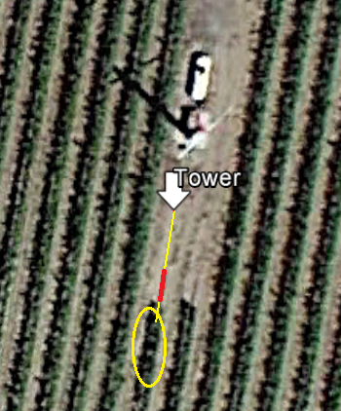

1. Well, dielectric permittivity, which is used to calculate volumetric water content (VWC) with the Topp eqn.